# Solving Challenge 3: The Black Box



1. Double click the *TheBlackBox.jar* challenge file to start it.
2. 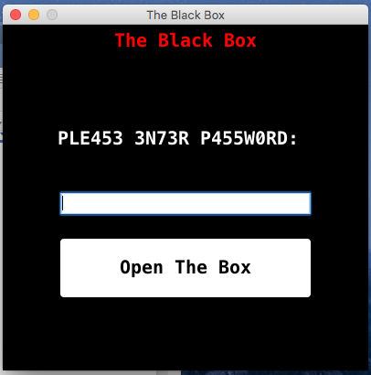The Black Box GUI will show up and challenge you to crack the password
3. 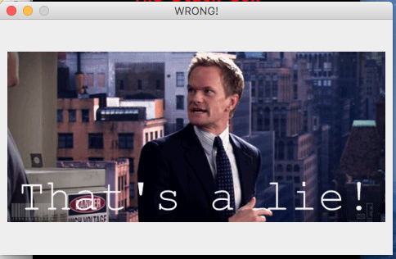Trying some passwords will pop up a “WRONG” gif window
4. 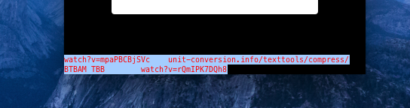Click around the graphical objects and discover the invisible text box and a text compression tool in it.
5. Unzip the jar to reverse engineer and discover the code for more hints



You can also use a more convenient online tool like: <http://www.javadecompilers.com/>

Choose TheBlackBox.jar from your computer, then press *Upload and Decompile*



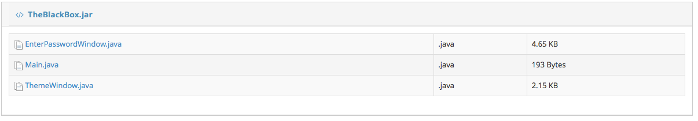

1. After a little bit of searching inside the files you’ll find a suspicious compressed text in the bottom of ThemeWindow.java:

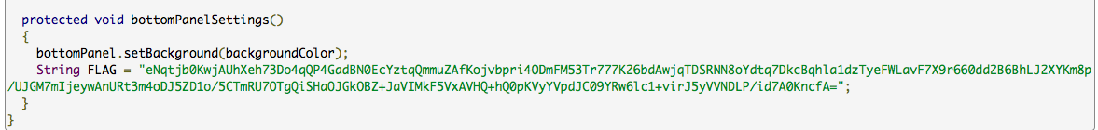

1. 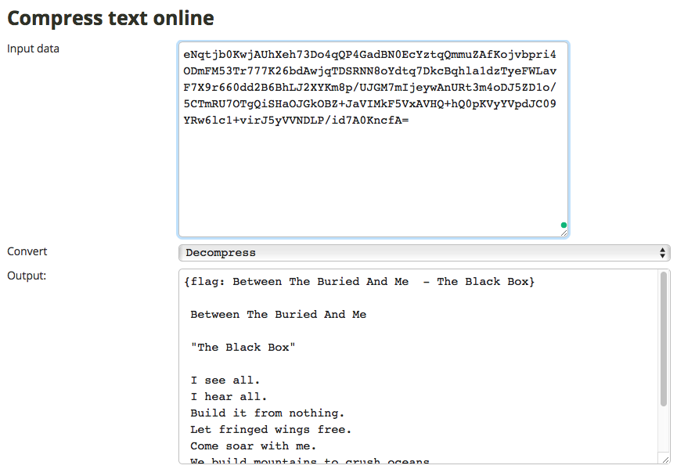Using the compression tool (choosing the decompress option) we found in the invisible text box to decompress the FLAG text we will discover the flag: